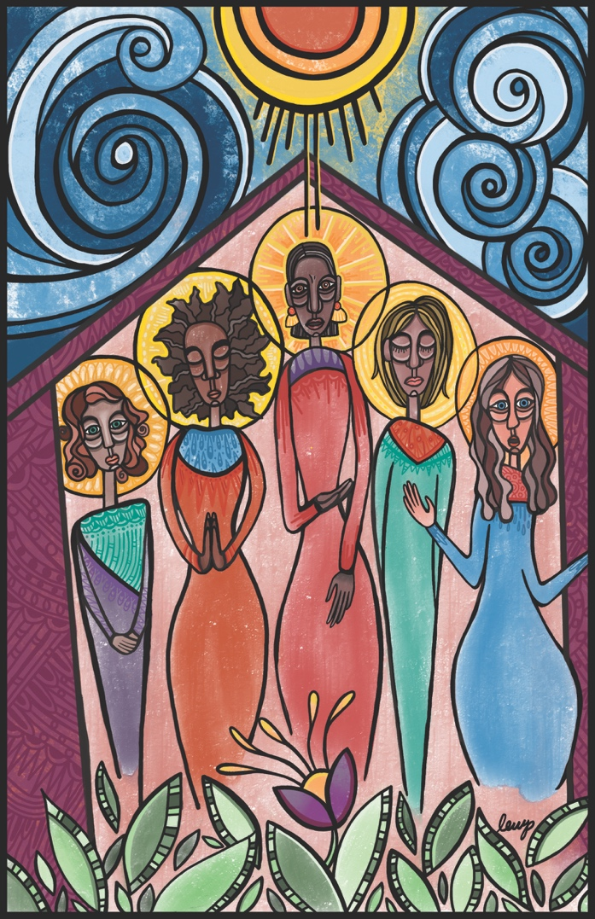

**"They Stood" by Lauren Wright Pittman | A Sanctified Art LLC | sanctifiedart.org**

**Sunday, September 17th**

**16th Sunday after Pentecost**

**The Eliot Church of Newton | 474 Centre St. | Newton, MA | 02458**

[**www.eliotchurch.org**](http://www.eliotchurch.org)

*We are an Open & Affirming Congregation of the United Church of Christ.*

**Welcome!**

We are so happy you are here, whether you joined us for worship online or in person. Know that whoever you are, and wherever you are on life’s journey, you are welcome here in this sacred space.

**If you are here for the first time,** please fill out a visitor card which you find in a pew. We would love to be in touch with you. If you visit us through our livestream, please feel free to contact our pastor who would love to connect with you.

**To our families**: we love the laughter and joy of children! We created a safe space in the back of our sanctuary. You are welcome to sit and play at this pray-ground throughout the service and after. Let us know if there is anything else you need!

**We have two hymnals:** One has a red cover (*Chalice*) and one has a black cover (*The New Century Hymnal*). We will always announce the hymns and in which hymnal they are. You can also see a red or black box before the hymn number on the sides of the wall.

**We sometimes stand** during the service to offer our reverence Be sure to be aware of the **asterisk (*)** in your bulletin. Wherever you see this symbol, we will invite you to stand. If there is no asterisk, you may remain seated.

**Contact Information:**

Pastor: Rev. Domenik Ackermann [revdom@eliotchurch.org](mailto:revdom@eliotchurch.org)

Office Administrator: Diahanna Hampton [office@eliotchurch.org](mailto:office@eliotchurch.org)

Director of Music Ministry: Monique Weiss Byrnes [music@eliotchurch.org](mailto:music@eliotchurch.org)

Facility Manager: Guy Burn [facility.manager@eliotchurch.org](mailto:facility.manager@eliotchurch.org)

Worship/Event Coordinator: Audrey Cunningham [events@eliotchurch.org](mailto:events@eliotchurch.org)

**We Enter for Worship**

**WELCOME**

**PRELUDE -** “*Fantasia in E minor*”, Johann Sebastian Bach, (1685-1750)

**\*CALL TO WORSHIP**  Psalm 95:1-2

*(*rise as you are able)*

One: O Come, Let us sing to our God;

**All: Let us make a joyful noise to the rock of our salvation!**

One: We come, O God, into your presence with thanksgiving,

**All: Rejoicing with songs of praise!**

**\*HYMN**  To God Compose a Song of Joy. **36 (NCH)**

**PRAYER OF TRANSFORMATION**

**O Source of Life, we praise you for listening to us. You hear us when we speak with you. As people of faith, we seek to listen to your word day in and out. We try to understand what you want us to do and live by. Yet, in times of crises or transformation, we realize that we sometimes do not hear your word. In some moments, we fail to listen to the moments and people that reveal your word because we are preoccupied, doubtful, or we just don’t trust those who reveal it. Open our hearts and minds so we can listen to the voice of your Spirit that leads and guides us now and always. Amen.**

**SILENCE**

**WORDS OF GRACE**

**ACT OF PRAISE**

**PASSING THE PEACE**

**We Listen to God’s Word**

**READING Numbers 27:1-11**

Then the daughters of Zelophehad came forward. Zelophehad was son of Hepher son of Gilead son of Machir son of Manasseh son of Joseph, a member of the Manassite clans. The names of his daughters were: Mahlah, Noah, Hoglah, Milcah, and Tirzah. They stood before Moses, Eleazar the priest, the leaders, and all the congregation, at the entrance of the tent of meeting, and they said, “Our father died in the wilderness; he was not among the company of those who gathered themselves together against the LORD in the company of Korah, but died for his own sin; and he had no sons. Why should the name of our father be taken away from his clan because he had no son? Give to us a possession among our father’s brothers.”

Moses brought their case before the LORD. And the LORD spoke to Moses, saying: The daughters of Zelophehad are right in what they are saying; you shall indeed let them possess an inheritance among their father’s brothers and pass the inheritance of their father on to them. You shall also say to the Israelites, “If a man dies, and has no son, then you shall pass his inheritance on to his daughter. If he has no daughter, then you shall give his inheritance to his brothers. If he has no brothers, then you shall give his inheritance to his father’s brothers. And if his father has no brothers, then you shall give his inheritance to the nearest kinsman of his clan, and he shall possess it. It shall be for the Israelites a statute and ordinance, as the LORD commanded Moses.”

**HYMN** God, Speak to Me, That I May Speak **531 (NCH)**

**SERMON**

**We Respond**

**ANTHEM -** “Be Still for the presence of the Lord”, David J. Evans, (b.1957)

Be still, for the presence of the Lord, the Holy One is here. Come, bow before him now, with reverence and fear. In him no sin is found, we stand on holy ground; be still, for the presence of the Lord, the Holy One, is here. Be still, for the glory of the Lord is shining all around; He burns with holy fire, with splendour he is crowned. How awesome is the sight, our radiant King of light! Be still, for the glory of the Lord is shining all around. Be still, for the power of the Lord is moving in this place; He comes to cleanse and heal, to minister his grace. No work too hard for him, in faith receive from him; Be still, for the power of the Lord is moving in this place.

**PASTORAL PRAYER**

**THE LORD’S PRAYER**

**Our Father,* which art in heaven, hallowed be thy name.**

**Thy kingdom come, thy will be done on earth as it is in heaven.**

**Give us this day our daily bread, and forgive us our debts,**

**As we forgive our debtors.**

**And lead us not into temptation but deliver us from evil:**

**For thine is the kingdom, and the power, and the glory, forever,**

**Amen.**

*(*Jesus addressed God as Abba (father) in this prayer to voice his relationship with God. You may use another address that feels comfortable to you (mother, sister, God, Creator, etc.)*

**PASSING THE PEACE**

**OFFERTORY** **ANTHEM** - “Lord, in thy mercy”, Felix Mendelssohn, (1809-1847)

Lord, in thy mercy grant us thy peace throughout all generations; thou art alone our sword and shield, Lord who dost guide the nations. Defend us, O God, we pray thee.

**\*DOXOLOGY**  **780 (NCH**)

Praise God from whom all blessings flow;

Praise God all creatures here below;

praise God above, you heavenly host.

Creator, Christ and Holy Ghost.

**We go into the World**

**ANNOUNCEMENTS**

**\*HYMN** God, Dismiss Us With your Blessing 439 **(Chalice)**

**BENEDICTION**

**POSTLUDE** “*Voluntary in G*”, John Stanley, (1712-1786)

Chancel Choir: Elizabeth Baker, Aaron McPherson, Alison McPherson, Rebekah Mitsein

Section Leaders: Nicola Santoro, Caitlin Winston, Connor Burke

**Today’s Service**

Pastor: Rev. Domenik Ackermann

Director of Music Ministry: Monique Weiss Byrnes

Reader: Vince Maraventano

Coffee Host: Alice Holt

Worship Coordinator: Audrey Cunningham

**Join us for refreshments in the chapel after worship**

**Announcements & Upcoming Events**

**Queer Eye Bible Study** *Thursdays, 6-7 PM on Zoom*

This year, the UCC voted to actively affirm transgender people. This Bible Study's goal is to re-engage in Biblical Scriptures through the "queer lens." How can the Bible help us actively affirm LGBTQ+ people through our faith?

**Eliot Chancel Choir** *Thursdays***,** *7 pm – 8 pm - Sanctuary*

Chancel choir is welcoming new singers.

Please contact Monique Weiss Byrnes, Director of Music Ministry, at [music@eliotchurch.org](mailto:music@eliotchurch.org), if you are interested in singing with chancel choir

and have not sung with the choir.

**Game Night** *Friday, September 29, 7-8 PM in the Chapel*

Our kick-off game night of the year. Bring your favorite game. We’ll have food and snacks ready.

**Taizé Service** *Sunday, Oct 1, 7-8 PM in the Sanctuary*

Join us for a moment of peace and quiet. Make some space away from the daily routine and immerse yourself in candlelight and song. We’ll sing the beautiful hymns of Taizé and ponder and pray.

**Messy Tuesday** *Tuesday, Oct 10, 5:30 – 6:30 PM in the Sanctuary*

Let the kids play and meet other families. We open our Fellowship Hall with all our toys. Kids can run around and play, parents can sit and meet. A casual way to get connected. Light & kid-friendly supper include.