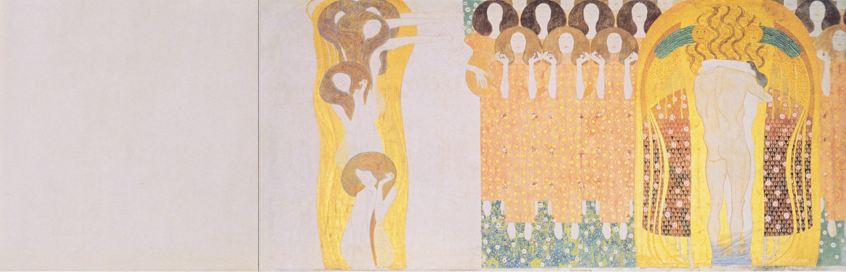
Sunday, December 17, 2023
3rd Sunday of Advent

The Eliot Church of Newton | 474 Centre St. | Newton, MA | 02458
www.eliotchurch.org

We are an Open & Affirming Congregation of the United Church of Christ.
Welcome!
We are so happy you are here, whether you joined us for worship online or in person. Know that whoever you are, and wherever you are on life’s journey, you are welcome here in this sacred space.
If you are here for the first time, please fill out a visitor card which you find in a pew. We would love to be in touch with you. If you visit us through our livestream, please feel free to contact our pastor who would love to connect with you.
To our families: We love the laughter and joy of children! We created a safe space in the back of our sanctuary. You are welcome to sit and play at this pray-ground throughout the service and after. Let us know if there is anything else you need!
We have two hymnals: One has a red cover (Chalice) and one has a black cover (The New Century Hymnal). We will always announce the hymns and in which hymnal they are. You can also see a red or black box before the hymn number on the sides of the wall.
We sometimes stand during the service to offer our reverence Be sure to be aware of the asterisk (*) in your bulletin. Wherever you see this symbol, we will invite you to stand. If there is no asterisk, you may remain seated.
Contact Information:
Pastor: Rev. Domenik Ackermann revdom@eliotchurch.org
Office Administrator: Deb Raymond office@eliotchurch.org
Director of Music Ministry: Monique Weiss Byrnes music@eliotchurch.org
Facility Manager: Guy Burn facility.manager@eliotchurch.org
WELCOME

PRELUDE - “Pastorale” from “The Messiah”, George Frederic Handel, (1685-1759)

*CALL TO WORSHIP
(*rise as you are able)

One: Praise God! Praise God from the heavens; Praise God everywhere!
All: Praise God, all ye angels! Praise God, sun, and moon! Praise God, oh shining stars!
One: Let all creation praise God! Glory in the Highest!
All: Glory in the Highest, Alleluia!

*HYMN Praise to the Living God 8 (NCH)

LIGHTING THE ADVENT WREATH

PRAYER OF ILLUMINATION
Holy One, In this Christmas Season we come before you in awe and joy for your ultimate gift to us: The gift of being present among us. Your presence illuminates us; your presence surrounds us with blessing, grace, and love. May we, in this season and always, carry this gift within us and give this gift to one another. We pray in Jesus’s name, Amen.

PASSING THE PEACE
*SONG OF PRAISE

READING Luke 2:22-40
“When the time came for their purification according to the law of Moses, they brought him up to Jerusalem to present him to the Lord (as it is written in the law of the Lord, “Every firstborn male shall be designated as holy to the Lord”), and they offered a sacrifice according to what is stated in the law of the Lord, “a pair of turtledoves or two young pigeons.”
Now there was a man in Jerusalem whose name was Simeon; this man was righteous and devout, looking forward to the consolation of Israel, and the Holy Spirit rested on him. It had been revealed to him by the Holy Spirit that he would not see death before he had seen the Lord’s Messiah. Guided by the Spirit, Simeon came into the temple; and when the parents brought in the child Jesus, to do for him what was customary under the law, Simeon took him in his arms and praised God, saying,
“Master, now you are dismissing your servant in peace, according to your word;
for my eyes have seen your salvation,
which you have prepared in the presence of all peoples,
a light for revelation to the Gentiles and for glory to your people Israel.”
And the child’s father and mother were amazed at what was being said about him. Then Simeon blessed them and said to his mother Mary, “This child is destined for the falling and the rising of many in Israel, and to be a sign that will be opposed so that the inner thoughts of many will be revealed—and a sword will pierce your own soul too.”
There was also a prophet, Anna the daughter of Phanuel, of the tribe of Asher. She was of a great age, having lived with her husband seven years after her marriage, then as a widow to the age of eighty-four. She never left the temple but worshiped there with fasting and prayer night and day. At that moment she came, and began to praise God and to speak about the child to all who were looking for the redemption of Jerusalem.
When they had finished everything required by the law of the Lord, they returned to Galilee, to their own town of Nazareth. The child grew and became strong, filled with wisdom; and the favor of God was upon him.”
VOCAL SOLO - “Rejoice Greatly, O Daughter of Zion”, George Frederic Handel, (1685-1759) - Nicola Santoro – Soprano
Rejoice greatly, O daughter of Sion, shout, O daughter of Jerusalem: behold, thy King cometh unto thee. He is the righteous Saviour, and He shall speak peace unto the heathen.
SERMON
HYMN My Heart Sings Out with Joyful Praise 106 (NCH)
PASTORAL PRAYER

THE LORD’s PRAYER
Our Father,* which art in heaven, hallowed be thy name.
Thy kingdom come, thy will be done on earth as it is in heaven.
Give us this day our daily bread, and forgive us our debts,
As we forgive our debtors.
And lead us not into temptation but deliver us from evil:
For thine is the kingdom, and the power, and the glory, forever,
Amen.

(*Jesus addressed God as Abba (father) in this prayer to voice his relationship with God. You may use another address that feels comfortable to you (mother, sister, God, Creator, etc.)

OFFERTORY

OFFERTORY ANTHEM - “Glory to God”, George Frideric Handel, (1685-1759)
Glory to God! Glory to God in the highest, And peace on earth. Glory to God! Glory to God! Glory to God in the highest, And peace on earth. Goodwill toward men.
*DOXOLOGY 780 (NCH)
Praise God from whom all blessings flow;
Praise God all creatures here below;
praise God above, you heavenly host.
Creator, Christ and Holy Ghost.
ANNOUNCEMENTS

*HYMN Lift Up Your Heads, O Mighty Gates 117 (NCH)

*DISMISSAL & BENEDICTION

POSTLUDE - “Improvisation on Veni Emmanuel”, Monique Weiss Byrnes, (1685-1750)

Today’s Service
Cover image: Gustav Klimt: “Choir of angels from Paradise. 'Joy, lovely spark of heaven's fire, this embrace for all the world.” , Public Domain
Credits: Words of Worship adopted from “Those Who Dream” by A Sanctified Art
Pastor: Rev. Domenik Ackermann
Director of Music Ministry: Monique Weiss Byrnes
Coffee Host: Thomas Theara
Greeter:
Worship Coordinator:

Chancel Choir: Alison McPherson, Rebekah Mitsein, Elizabeth Baker, Aaron McPherson
Section Leaders: Nicola Santoro, Caitlin Winston, Connor Burke

Upcoming Events

Eliot Chancel Choir Thursdays, 7 pm – 8 pm - Sanctuary
Chancel choir is welcoming new singers.
Please contact Monique Weiss Byrnes, Director of Music Ministry, at music@eliotchurch.org, if you are interested in singing with chancel choir and have not sung with the choir

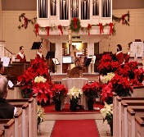 Advent Journey! with Mary, the Mother of Jesus
This 15-minute program will include Advent carols, motets and brief reflections focusing on Mary, the Mother of Jesus. Seasonal refreshments will be provided at the conclusion. Presented by The Eliot Music Committee.
Sunday, Dec 17, after worship. Held in the Chapel

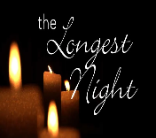 Not Quite the Longest Night Service
Join us for a Longest Night-style service on almost the longest night of the year. Together with United Parish Auburndale and Newton Presbyterian Church.
Held at Newton Presbyterian Church
70 Vernon St. Newton, MA 01754
Wednesday Dec. 20 at 7pm

Christmas Eve Candlelight Service
We look forward to celebrating Christmas with you this year: Join us for our All Ages Candlelight Service
Sunday Dec 24 at 6pm

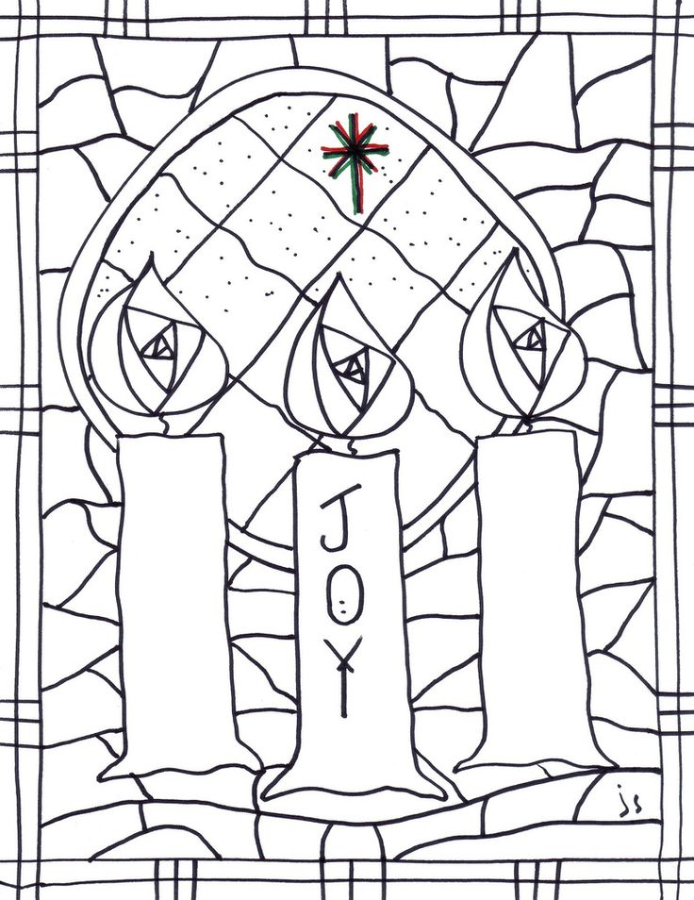

Coloring picture 3rd week of Advent
